半年为周期，训练时间201312-201511，预测201512-201606,滑窗大小为1：

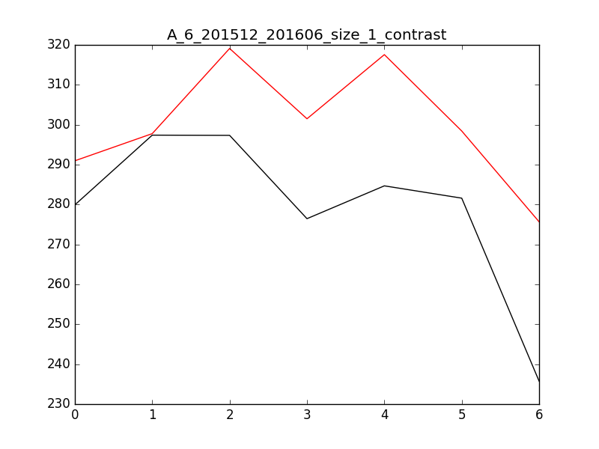

数据对比,左边预测值，右边真实值：

201512: 290.965251453 279.918411946

201601: 297.767000664 297.387040044

201602: 319.102986521 297.338653353

201603: 301.491302827 276.461195778

201604: 317.560736893 284.684699341

201605: 298.426978609 281.602107366

201606: 275.680532186 235.751433269

半年为周期，训练时间201312-201511，预测201512-201606,滑窗大小为3：

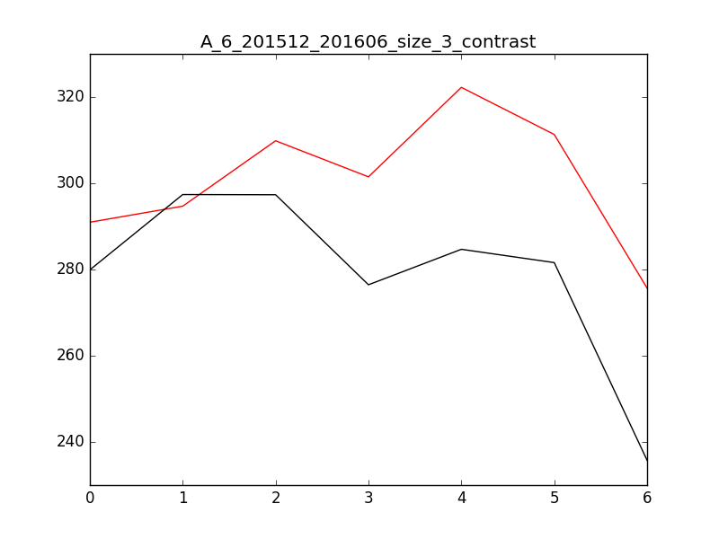

数据对比,左边预测值，右边真实值：

201512: 290.965251453 279.918411946

201601: 294.68600183 297.387040044

201602: 309.854493231 297.338653353

201603: 301.491302184 276.461195778

201604: 322.238825153 284.684699341

201605: 311.318146761 281.602107366

201606: 275.680532873 235.751433269

半年为周期，训练时间201312-201511，预测201512-201606,滑窗大小为7：

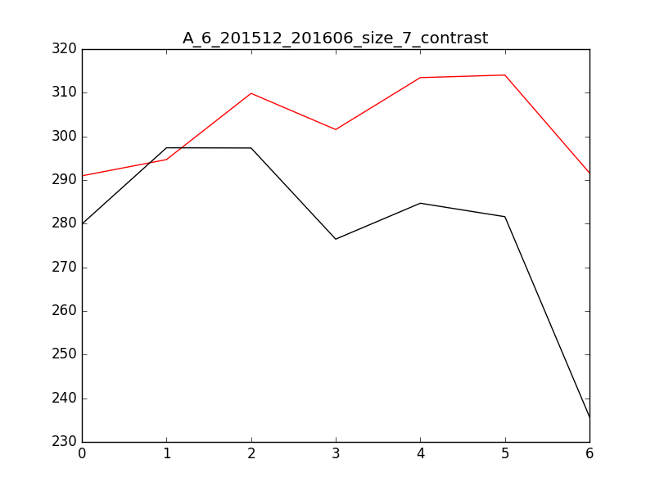

数据对比,左边预测值，右边真实值：

201512: 290.965254925 279.918411946

201601: 294.68600988 297.387040044

201602: 309.854496679 297.338653353

201603: 301.571635607 276.461195778

201604: 313.468278955 284.684699341

201605: 314.050831258 281.602107366

201606: 291.629165119 235.751433269

半年为周期，训练时间201312-201605，预测时间201606-201608，滑窗大小为1：

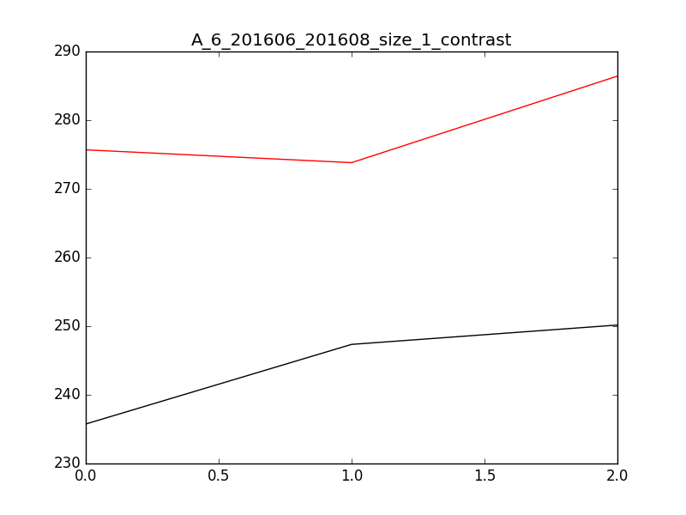

数据对比,左边预测值，右边真实值：

201606: 275.680531847 235.751433269

201607: 273.813836701 247.345597846

201608: 286.41337334 250.163619758

半年为周期，训练时间201312-201605，预测时间201606-201608，滑窗大小为3：

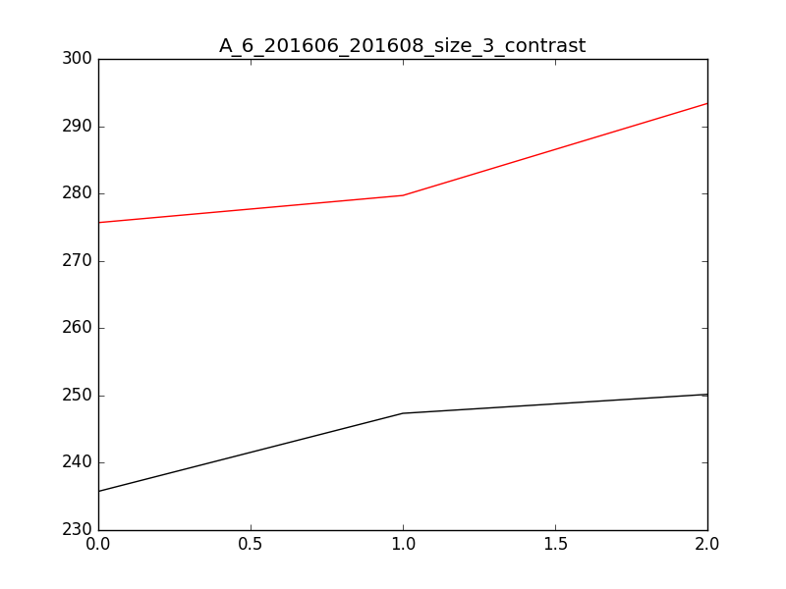

数据对比,左边预测值，右边真实值：

201606: 275.680529177 235.751433269

201607: 279.710580642 247.345597846

201608: 293.380912594 250.163619758

半年为周期，训练时间201312-201605，预测时间201606-201608，滑窗大小为7：

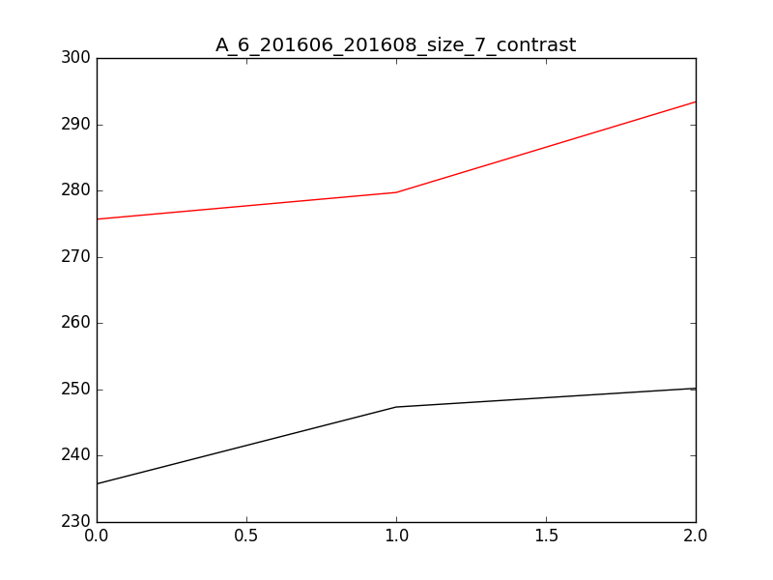

数据对比,左边预测值，右边真实值：

201606: 275.680529177 235.751433269

201607: 279.710580642 247.345597846

201608: 293.380912594 250.163619758

半年为周期，训练时间201312-201505，预测时间201506-201512, 滑窗大小为1:

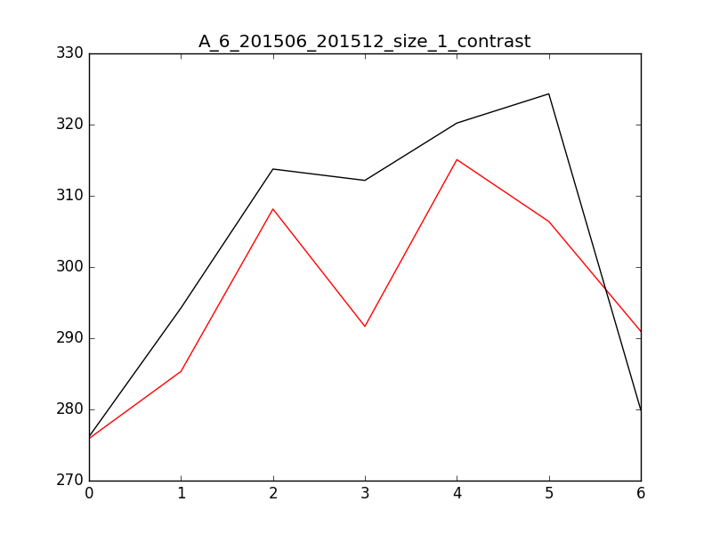

数据对比，左边为预测值，右边为实际值：

201506: 275.909995052 276.170014415

201507: 285.3329668 294.244397834

201508: 308.144925359 313.75617244

201509: 291.656600332 312.164223568

201510: 315.082132125 320.216716155

201511: 306.393341717 324.318952813

201512: 290.965250954 279.918411946

半年为周期，训练时间201312-201505，预测时间201506-201512, 滑窗大小为3:

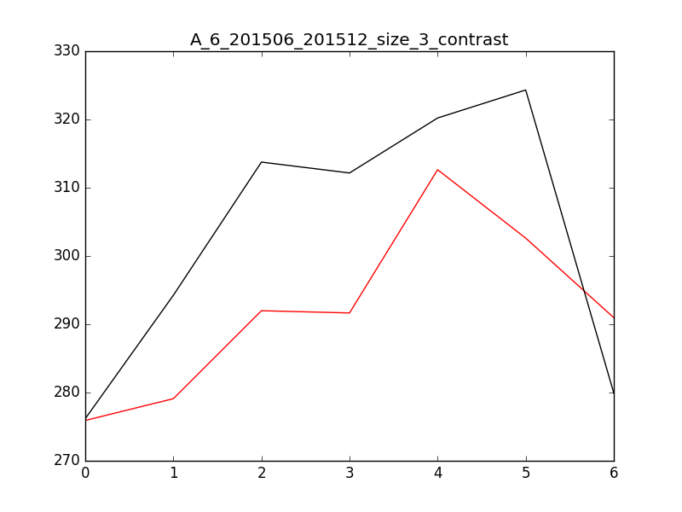

数据对比，左边为预测值，右边为实际值：

201506: 275.909995052 276.170014415

201507: 279.097909549 294.244397834

201508: 291.985311589 313.75617244

201509: 291.656609671 312.164223568

201510: 312.641733013 320.216716155

201511: 302.621284901 324.318952813

201512: 290.965250954 279.918411946

半年为周期，训练时间201312-201505，预测时间201506-201512, 滑窗大小为7

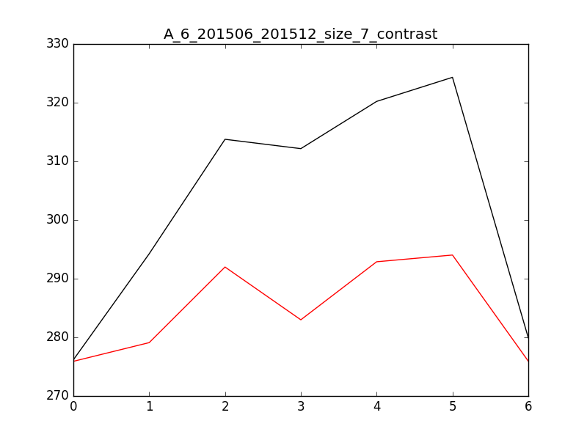

数据对比，左边为预测值，右边为实际值：

201506: 275.909980935 276.170014415

201507: 279.097905806 294.244397834

201508: 291.985331484 313.75617244

201509: 282.989738823 312.164223568

201510: 292.882303556 320.216716155

201511: 294.028528309 324.318952813

201512: 275.935352117 279.918411946